2019 TLP Arm Strength and Velocity Program

We would like to start out by saying thank you for your interest in our Arm Strength and Velocity program. We have worked very hard to put together a program in which we combine expert instruction and state of the art equipment, along with a fair price. We have contracted with Randall Fields the Eastern Wayne High School Varsity baseball coach to lead this course. We will be using a modified Driveline throwing program to help your athlete become stronger and develop better arm care habits. Randall has modified the program and removed some things that we feel could be detrimental to the arm. Our program will be 3 months in length and will start September 2nd, 2019. With this program we will meet twice a week on Mondays and Thursdays. On the other days your athlete will be given a workout to complete on their own time. They must do these workouts to see results. In order to make this program cost effective to the parents we have chosen to make this a two day a week in house training versus five days a week. We also will require a 3-month commitment to this program. The program progresses as we move forward so it does require a full 3 months. After the 3 months the athlete will need to do a maintenance program that they will be given. If you cannot commit to the 3-month program, please do not register for this program. There will be some equipment that you will be required to purchase if you do not want to work out at TLP on your off days. You will be required to have a set of Driveline plyo balls, Jaeger Bands, and a mini trampoline (The trampoline is optional). If you already have any of these items, then you will not need to re purchase items. These items will be yours to keep at home and will not need to be brought to TLP. We will have all these items in bulk here. This program will not guarantee that your athlete will increase their velocity. This program if done correctly and your athlete puts in the work at home will garner results. Attached on the next page will be a list and picture of the items you need to purchase before class starts. Since we are pro members of driveline, we can purchase these items at a discounted rate and will be placing an order the second week of August. If you bring us the money, we will order your items for you and have them ready by the first day of class. Below will be the breakdown in pricing for the training.
Non TLP Member will be $375 plus cost of additional equipment ($125.00 Monthly)
TLP Member will be $300 plus cost of the additional equipment ($100.00 Monthly)
This can be paid up front or monthly. These prices include use of the facility, our equipment, and instructors’ fees. The number of students will determine how many instructors we will have. Zack Mozingo formerly of the Tampa Bay Rays organization will be assisting this program as well.
If you would like to train at TLP on your off days and not purchase the equipment that will be fine. We will have all the necessary equipment at TLP for your use during this program.

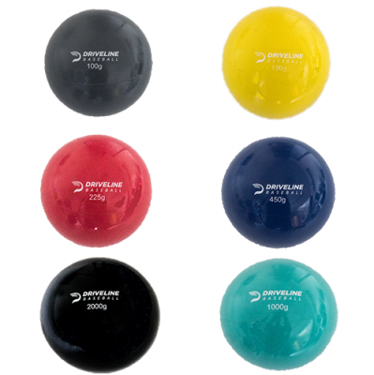 Driveline Plyo balls $50.00 (You will be required to have these balls and no other brand will work. These are weighted and color coated to go with the program)

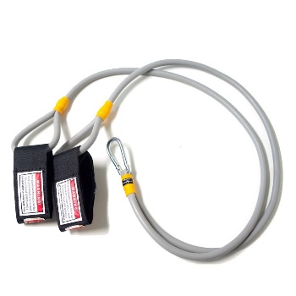J-Bands $35 (You will need this brand band and if you shop online this is the cheapest you will find them)
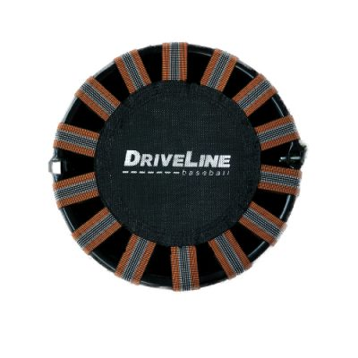Mini Trampoline $50.00 (You can use any brand trampoline, but this is the driveline one. There are some internet shops that have different versions cheaper)

